**The hypoxic burden of sleep apnea predicts cardiovascular disease-related mortality: The Osteoporotic Fractures in Men Study and the Sleep Heart Health Study.**

Ali Azarbarzin, PhD1, Scott A Sands, PhD1, Katie L Stone, PhD2, Luigi Taranto-Montemurro, MD1, Ludovico Messineo, MD1, Philip I Terrill, PhD3, Sonia Ancoli-Israel, PhD4, Kristine Ensrud, MD5, Shaun Purcell, PhD1,6, David P White, MD1, Susan Redline, MD1, Andrew Wellman, MD, PhD1

1Division of Sleep and Circadian Disorders, Brigham and Women's Hospital and Harvard Medical School, Boston, MA; 2Research Institute, California Pacific Medical Center, San Francisco, CA;3School of Information Technology and Electrical Engineering, The University of Queensland, Brisbane, Australia; 4Departments of Psychiatry and Medicine, University of California San Diego, La Jolla, California and Department of Veterans Affairs San Diego Center of Excellence for Stress and Mental Health (CESAMH); 5University of Minnesota and Minneapolis Veterans Affairs Health Care System, Minneapolis, Minnesota; 6Stanley Center for Psychiatric Research, Broad Institute of MIT & Harvard, Cambridge, MA.

**Online Supplement**

*Robust computation of hypoxic burden*

The hypoxic burden was defined as the total area under the respiratory event-related desaturation curve. For each individually identified apnea or hypopnea, the pre-event baseline saturation was defined as the maximum SpO2 during the 100 seconds prior to the end of the event. The area under this baseline value was calculated over a subject-specific search window (shown in Figure 1) for each event. For a robust area calculation, the subject-specific search window was obtained from an averaged desaturation curve. The average desaturation curve for each participant was determined by overlaying SpO2 signals with respect to the end of events.

This search window is particularly important when the start and end of an oxygen desaturation event cannot be determined accurately (e.g. events without a clear SpO2 recovery to the baseline value). In these cases, to estimate the associated area under the desaturation curve, the average desaturation curve is beneficial to determine the search window. This information can be used to minimize the artifacts and estimate the area under the desaturation curve when the SpO2 lacks a clear start and end for a given respiratory event.

*Hypoxic burden as a measure of depth, duration, and frequency of respiratory events*

The hypoxic burden captures the duration, the depth, and the frequency of respiratory events. This is because the hypoxic burden can be approximated by the multiplication of AHI and the area under the *average* desaturation curve (Figure 1), which may be considered as a triangle with its height and base being the desaturation depth and the desaturation duration. As a result, the hypoxic burden can be approximated by *AHI× (Desaturation Depth × Desaturation Duration)/2.* Hence, it is a measure of duration, depth, and frequency of respiratory event-related desaturations.

*Hypoxic Burden and Apnea-Hypopnea Index distributions in MrOS and SHHS*

C:\Users\aa206\Desktop\Ali\Papers\Azarbarzin Predicting mortality\European Heart Journal\Revision 1\Final\Published-Proof\erratum\AHI-HB_Histogram.tiff

Figure S1: Distribution of apnea-hypopnea index and hypoxic burden in MrOS and SHHS.

*Cardiovascular mortality adjusted hazard ratios for all covariates in model 4*

**Table S1: CVD mortality adjusted hazard ratios for hypoxic burden and covariates in model 4 in MrOS**

|  |  |  |  |
| --- | --- | --- | --- |
| Variables | N | Deaths | Hazard Ratio (95% CI) |
| Age, per 5 years | 2743 | 440 | **1.93 (1.75, 2.12) \*\*\*** |
| BMI, per 5 kg/m2 | 2743 | 440 | 1.12 (0.97, 1.30) |
| Race |  |  |  |
| Caucasian | 2489 | 411 | 1.00 |
| African American | 92 | 8 | 0.68 (0.33, 1.42) |
| Other race | 162 | 21 | 0.95 (0.60, 1.51) |
| Alcohol: |  |  |  |
| <1 glasses/week | 1268 | 218 | 1.00 |
| 1-13 glasses/week | 1326 | 202 | 0.94 (0.76, 1.15) |
| 14+ glasses/week | 149 | 20 | 0.83 (0.52, 1.34) |
| Smoking Status |  |  |  |
| Never | 1097 | 164 | 1.00 |
| Former | 1594 | 271 | **1.24 (1.02, 1.52) \*** |
| Current | 52 | 5 | 1.44 (0.58, 3.55) |
| Chronic Obstructive Pulmonary Disease | 142 | 19 | 0.79 (0.49, 1.28) |
| Renal Failure | 26 | 7 | **2.47 (1.14, 5.38) \*** |
| Diabetes | 355 | 84 | **1.63 (1.27, 2.10) \*\*\*** |
| Hypertension | 1361 | 272 | **1.39 (1.13, 1.71) \*\*** |
| Stroke | 102 | 27 | 1.38 (0.91, 2.11) |
| Coronary Heart Disease | 785 | 195 | **1.92 (1.54, 2.39) \*\*\*** |
| Peripheral Vascular Disease | 276 | 74 | 1.34 (0.94, 1.91) |
| Claudication | 148 | 34 | 0.82 (0.51, 1.32) |
| Transient Ischemic Attack | 251 | 57 | 1.14 (0.84, 1.54) |
| Congestive Heart Failure | 160 | 58 | **1.84 (1.37, 2.48) \*\*\*** |
| Statin Use | 1130 | 196 | **0.78 (0.63, 0.96) \*** |
| Sleep Duration |  |  |  |
| 5-8 hours | 2191 | 336 | 1.00 |
| <5 hours | 481 | 92 | 1.16 (0.92, 1.47) |
| >8 hours | 71 | 12 | 1.24 (0.69, 2.22) |
| AHI, per 15 events/hour | 2743 | 440 | **0.80 (0.67, 0.95) \*** |
| TST90, per 10%TST | 2743 | 440 | 1.10 (0.97, 1.25) |
| MinSat, per % | 2743 | 440 | 1.04 (0.97, 1.11) |
| Hypoxic Burden |  |  |  |
| Q1 (<20 %minutes/hour) | 549 | 64 | 1.00 |
| Q2 (20-34 %minutes/hour) | 552 | 77 | 1.19 (0.85, 1.68) |
| Q3 (34-53 %minutes/hour) | 548 | 71 | 1.26 (0.88, 1.81) |
| Q4 (53-88 %minutes/hour) | 553 | 100 | **1.81 (1.25, 2.62) \*\*** |
| Q5 (>88 %minutes/hour) | 541 | 128 | **2.73 (1.71, 4.36) \*\*\*** |

**Table S2: CVD mortality adjusted hazard ratios for hypoxic burden and covariates in model 4 in SHHS**

|  |  |  |  |
| --- | --- | --- | --- |
| Variables | N | Deaths | Hazard Ratio (95% CI) |
| Age, per 5 years | 4672 | 313 | **2.02 (1.86, 2.19) \*\*\*** |
| Gender |  |  |  |
| Male | 2179 | 168 | 1.00 |
| Female | 2493 | 145 | 0.79 (0.62, 1.01) |
| BMI, per 5 kg/m2 | 4672 | 313 | 0.88 (0.77, 1.01) |
| Race |  |  |  |
| Caucasian | 4114 | 277 | 1.00 |
| Non-Caucasian | 558 | 36 | 0.87 (0.60, 1.26) |
| Smoking Status |  |  |  |
| Never | 2173 | 143 | 1.00 |
| Former | 442 | 21 | 1.49 (0.92, 2.39) |
| Current | 2057 | 149 | 1.12 (0.88, 1.43) |
| Chronic Obstructive Pulmonary Disease | 55 | 3 | 0.47 (0.15, 1.50) |
| Diabetes | 335 | 66 | **2.31 (1.74, 3.07) \*\*\*** |
| Hypertension | 1854 | 218 | **1.74 (1.34, 2.24) \*\*\*** |
| Stroke | 160 | 32 | 1.24 (0.84, 1.83) |
| Myocardial Infraction | 300 | 67 | **1.87 (1.33, 2.62)** **\*\*\*** |
| Angina | 350 | 62 | 1.32 (0.95, 1.84) |
| Coronary Artery Bypass Surgery | 164 | 37 | 1.39 (0.94, 2.05) |
| Coronary Angioplasty | 142 | 19 | 0.75 (0.46, 1.24) |
| Congestive Heart Failure | 81 | 21 | 1.52 (0.94, 2.48) |
| Lipid-Lowering Medication Use | 571 | 49 | 0.91 (0.66, 1.26) |
| Sleep Duration |  |  |  |
| 5-8 hours | 599 | 58 | 1.00 |
| <5 hours | 36 | 7 | **2.91 (1.30, 6.55) \*** |
| >8 hours | 4037 | 248 | 0.98 (0.73, 1.31) |
| AHI, per 15 events/hour | 4672 | 313 | 0.87 (0.74, 1.02) |
| TST90, per 10%TST | 4672 | 313 | **1.15 (1.04, 1.28) \*\*** |
| MinSat, per % | 4672 | 313 | 1.04 (0.96, 1.11) |
| Hypoxic Burden† |  |  |  |
| Q1 (<16 %minutes/hour) | 932 | 29 | 1.00 |
| Q2 (16-28 %minutes/hour) | 932 | 48 | 1.48 (0.93, 2.37) |
| Q3 (28-43 %minutes/hour) | 956 | 65 | 1.34 (0.85, 2.13) |
| Q4 (43-71 %minutes/hour) | 940 | 74 | 1.61 (1.00, 2.61) |
| Q5 (>71 %minutes/hour) | 912 | 97 | **1.96 (1.11, 3.43) \*** |

†In SHHS, the hypoxic burden quintiles were calculated using all 5111 participants’ data, shown in Figure S1.

*Fully adjusted CVD-related mortality hazard ratios for the log-transformed Hypoxic burden in MrOS and SHHS*

**Table S3: Hypoxic burden (log-transformed, base 10) predicts cardiovascular-related mortality in MrOS and SHHS. Unadjusted and adjusted Hazard ratios for hypoxic burden in different models**

|  |  |  |  |  |  |
| --- | --- | --- | --- | --- | --- |
| **Covariates** | **MrOS** | | **SHHS** | | |
| HR (95% CI) | p | | HR (95% CI) | p |
| Model 0: None | 2.04 (1.59, 2.61) | <0.001 | | 2.74 (2.06, 3.64) | <0.001 |
| Model 1: Anthropometric†, sleep duration, smoking, alcohol††, non-CVD medical history¶ | 1.57 (1.23, 1.99) | <0.001 | | 1.39 (1.03, 1.88) | <0.05 |
| Model 2a: Model 1 + AHI | 2.01 (1.37, 2.94) | <0.001 | | 1.79 (1.14, 2.82) | <0.05 |
| Model 2b: Model 1 + ODI | 1.69 (1.17, 2.44) | <0.01 | | 1.67 (1.13, 2.46) | <0.05 |
| Model 3: Model 2a + MinSat + TST90 | 2.12 (1.43, 3.13) | <0.001 | | 1.82 (1.15, 2.89) | <0.05 |
| Model 4: Model 3 + cardio-metabolic diseases§ | 2.03 (1.37, 3.00) | <0.001 | | 1.73 (1.08, 2.78) | <0.05 |

†Anthropometric/demographic variables included age, BMI, race, and gender (only in SHHS). ††The number of missing values for alcohol consumption was substantially large in SHHS, therefore, it was only available in MrOS. ¶Non-CVD medical history included chronic obstructive pulmonary disease (COPD) and renal failure (only available in MrOS). §Concurrent cardio-metabolic disease included hypertension, diabetes, stroke, congestive heart failure, concurrent cardiovascular disease (MrOS: coronary heart disease, peripheral vascular disease, claudication, myocardial infarction, angina, and transient ischemic attack; SHHS: angina, myocardial infarction, and coronary revascularization), and lipid-lowering medication use. AHI, apnea hypopnea index (3% criterion); ODI, oxygen desaturation index (≥3% desaturations); MinSat, event-associated minimum saturation; TST90, percent time spent below oxygen saturation of 90%.

*All-cause mortality fully adjusted hazard ratios for the Hypoxic burden quintiles in MrOS and SHHS*

**Table S4: All-cause mortality fully adjusted hazard ratios for hypoxic burden quintiles in model 4 in MrOS**

|  |  |
| --- | --- |
| **Hypoxic burden quintile** | **HR (95% CI)** |
| Q1 (≤20%minute/hour) | 1.00 (Reference) |
| Q2 (20-34 %minute/hour) | 1.08 (0.90, 1.30) |
| Q3 (34-53 %minute/hour) | 1.05 (0.86, 1.29) |
| Q4 (53-88 %minute/hour) | **1.25 (1.01, 1.55) \*** |
| Q5 (>88 %minute/hour) | **1.53 (1.15, 2.02) \*\*** |

In MrOS, model 4 was adjusted for age, BMI, race, alcohol consumption, chronic obstructive pulmonary disease (COPD), renal failure, hypertension, diabetes, stroke, congestive heart failure, coronary heart disease, peripheral vascular disease, claudication, myocardial infarction, angina, and transient ischemic attack, lipid-lowering medication use, apnea hypopnea index (AHI 3% criterion), event-associated minimum saturation (MinSat), percent time spent below oxygen saturation of 90% (TST90).

**Table S5: All-cause mortality fully adjusted hazard ratios for hypoxic burden quintiles in model 4 in SHHS**

|  |  |
| --- | --- |
| **Hypoxic burden quintile** | **HR (95% CI)** |
| Q1 (<16%minute/hour) | 1.00 (Reference) |
| Q2 (16-28 %minute/hour) | 0.95 (0.76, 1.18) |
| Q3 (28-43 %minute/hour) | 0.86 (0.69, 1.07) |
| Q4 (43-71 %minute/hour) | 1.05 (0.84, 1.32) |
| Q5 (>71 %minute/hour) | 1.03 (0.79, 1.36) |

In SHHS, model 4 was adjusted for age, BMI, race, gender, chronic obstructive pulmonary disease (COPD), hypertension, diabetes, stroke, congestive heart failure, angina, myocardial infarction, and coronary revascularization, lipid-lowering medication use, apnea hypopnea index (AHI 3% criterion); event-associated minimum saturation (MinSat), percent time spent below oxygen saturation of 90% (TST90).

*Associations between CVD mortality and conventional PSG parameters*

Table S6 demonstrates the associations between CVD mortality and conventional PSG parameters in partially adjusted models that included covariates in model 1 without hypoxic burden. AHI and event-associated minimum saturation (MinSat) were not associated with CVD mortality in either cohort. The association between TST90 and CVD mortality was only significant in SHHS but not MrOS. The association between ODI and CVD mortality was only significant in MrOS but not SHHS (Table S6).

**Table S6: Associations of routine polysomnography (PSG) parameters and cardiovascular-related mortality in MrOS and SHHS.**

|  |  |  |  |  |  |
| --- | --- | --- | --- | --- | --- |
| **PSG parameter** | **MrOS** | | **SHHS** | | |
| HR (95% CI) | p | | HR (95% CI) | p |
| AHI (per 15 events/hour) | 1.08 (0.98, 1.20) | 0.10 | | 1.03 (0.92, 1.15) | 0.60 |
| TST90 (per 10%) | 1.07 (0.98, 1.17) | 0.13 | | 1.14 (1.06, 1.22) | <0.001 |
| ODI (per 15 events/hour) | 1.11 (1.02, 1.22) | <0.05 | | 1.00 (0.98, 1.03) | 0.91 |
| MinSat (%) | 0.99 (0.95, 1.03) | 0.56 | | 0.96 (0.92, 1.01) | 0.15 |

These parameters were modeled separately. Each model was adjusted for age, BMI, race, total sleep time, COPD, smoking, alcohol consumption (only MrOS), renal failure (only MrOS) and gender (only SHHS). AHI, apnea hypopnea index (3% criterion); TST90, percent time spent below oxygen saturation of 90%; ODI, oxygen desaturation index (≥3% desaturations); MinSat, event-associated minimum saturation. It is worth noting that the results remained non-significant with or without transformation.

*Association between the hypoxic burden and conventional polysomnography parameters*

As an exploratory analysis, the Spearman’s correlation between the hypoxic burden and polysomnography parameters such as apnea-hypopnea index (AHI), oxygen desaturation index (ODI with desaturations>3%), sleep time below 90% oxygen saturation (TST90), arousal index (ArI), wake time after sleep onset (WASO), and total sleep time (TST) were quantified (Figure S2). Ideally, for patients with an AHI<5 events/hour, these measures are theoretically highly correlated because the number of respiratory events is small and the variability in different measures is minimal. On the other hand, in patients with severe sleep apnea (AHI>30), the correlations decrease to a great extent because the large number of respiratory events could potentially introduce variability in different measures. This could clearly be observed in Figures S2, in which the strength of different associations is shown for both MrOS and SHHS studies. Figure S3, shows scatter plots of hypoxic burden versus AHI and TST90. The variability in hypoxic burden increases substantially as AHI increases. For example, for an AHI of 40 events/hour, the hypoxic burden ranges from 40 to 300 %minute/hour, which is due to the variability in the depth and the duration of event-related oxygen desaturations that are not captured by AHI.

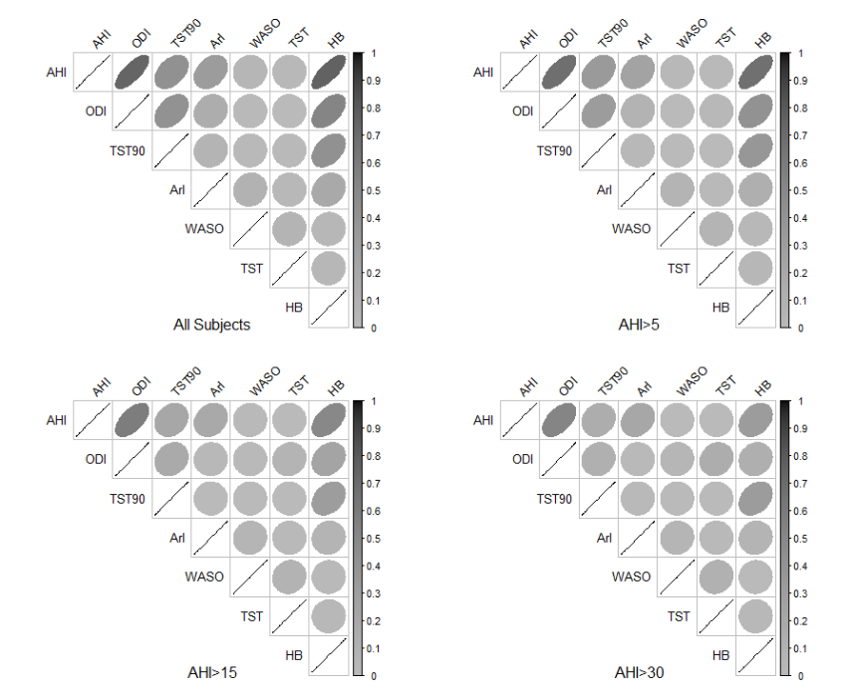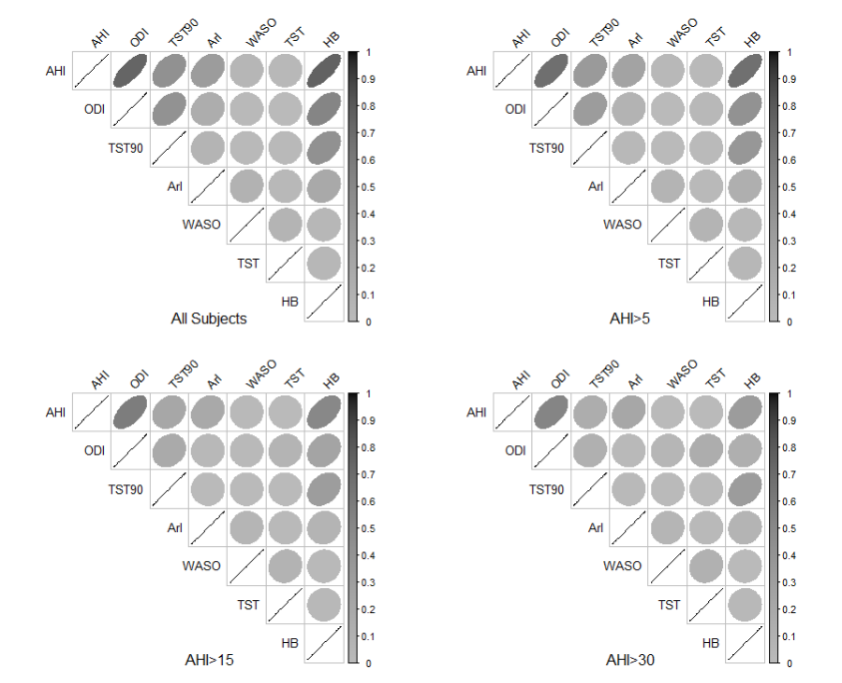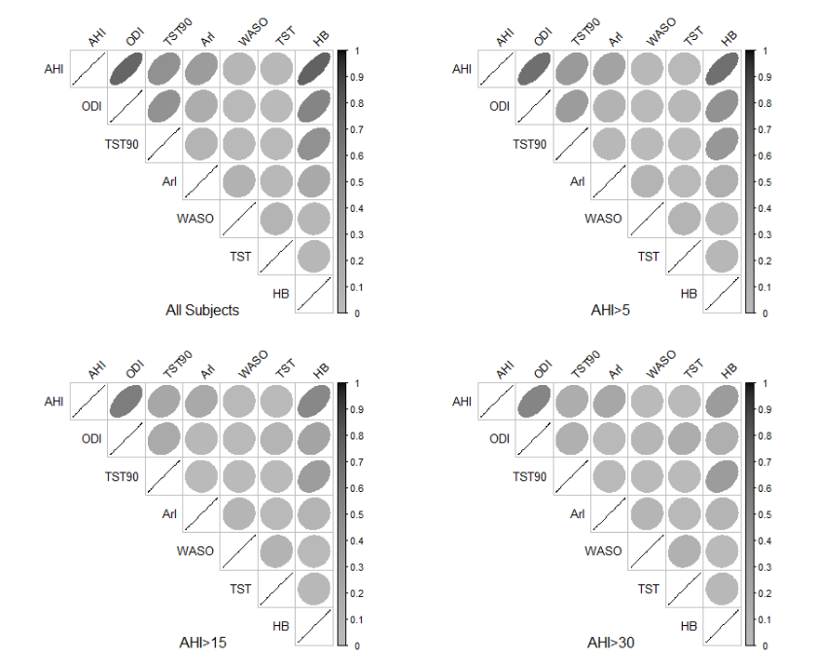

**(A)**

**(B)**

Figure S2: The association between hypoxic burden (HB) and conventional polysomnography variables in MrOS (panel A) and SHHS (panel B). The shape and the color of ellipses demonstrate the strength of association. A solid line represents a perfect association (R2=1) and a circle reflects no association between the corresponding two variables (R2=0). AHI, apnea-hypopnea index; ODI, oxygen desaturation index; TST90, sleep time below 90% oxygen saturation; WSat, resting oxygen saturation; ArI, arousal index; WASO, wake time after sleep onset; TST, total sleep time.

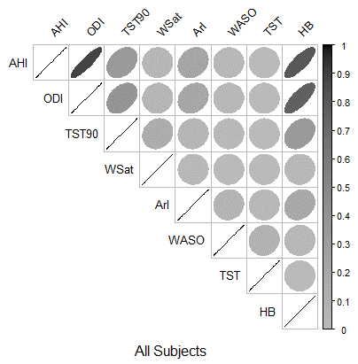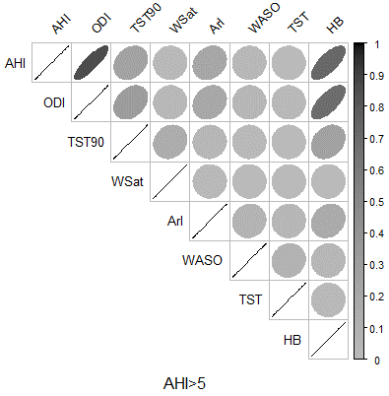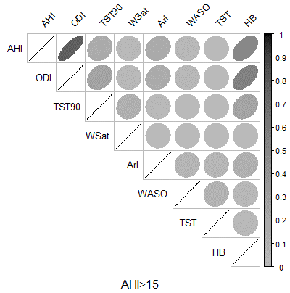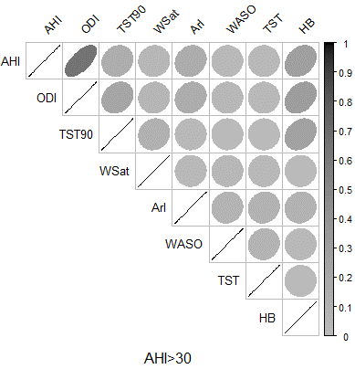

**(A)**

**(B)**

Figure S3: Scatter plots of hypoxic burden (HB) versus apnea-hypopnea index (AHI) and the sleep time below 90% oxygen saturation (TST90) for MrOS study (panel A) and SHHS study (panel B). The association between hypoxic burden and AHI weakens as AHI increases. Also, the hypoxic burden and TST90 are poorly correlated in both studies.

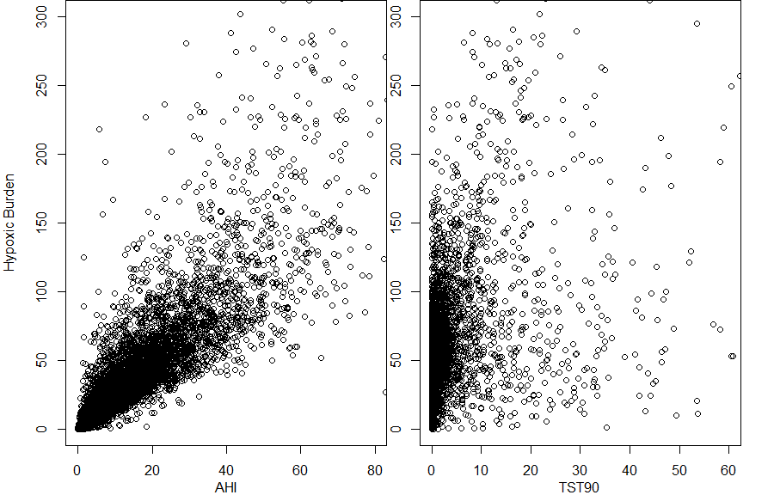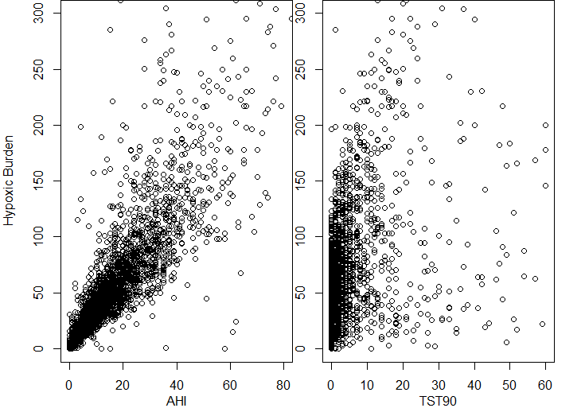

*Impact of desaturation depth on cardiovascular mortality in MrOS*

One of the limitations of hypoxic burden measure is that it does not distinguish between short/deep and long/shallow desaturations. As an example, the hypoxic burden of 20%min/hour could be due to 20 minutes of 1% desaturation or 5 minutes of 4% desaturation. Biologically, these two patterns could potentially have different impacts on cardiovascular system, which is not captured by the hypoxic burden as described in this paper. To further investigate this, we performed additional analyses in MrOS cohort. Briefly, for each patient, event-associated desaturations from pre-event baseline (as described previously) were obtained. To examine the impact of desaturation depth, the identified event-associated desaturations were transformed using 1) square-root, 2) no transform, and 3) square (power 2). Then, the total area under these transformed desaturations were calculated and divided by the total sleep time (Figure S4). Note that untransformed desaturation yields the original hypoxic burden described in this paper and the square-transformed desaturation results in exaggerated hypoxic burden for larger desaturations. These three versions of hypoxic burden were log-transformed, standardized, and modeled using Cox regression analysis. We used model 2a (as described in Table 3), which included age, BMI, race, smoking, alcohol consumption, total sleep time, COPD, and renal failure, to compare the standardized hazard ratios for different forms of hypoxic burden (Table S7).

**Table S7: Associations of three modifications of hypoxic burden and cardiovascular-related mortality in MrOS.**

|  |  |  |
| --- | --- | --- |
| **Transformation** | **MrOS** | |
| HR (95% CI) | p |
| Square root | 1.79 (1.28, 2.50) | 0.0007 |
| None | 1.86 (1.33, 2.61) | 0.0003 |
| Square | 1.81 (1.33, 2.47) | 0.0002 |

The transformed versions of hypoxic burden were modeled separately. Each model was adjusted for age, BMI, race, total sleep time, COPD, smoking, alcohol consumption, renal failure, and AHI.

Figure S4: The modified versions of hypoxic burden to account for the impact of desaturation depth on cardiovascular mortality. The square transform of desaturation resulted in diminished area for small desaturations and exaggerated area for larger desaturations.

